**DUKE NYAKUNDI MARUBE**

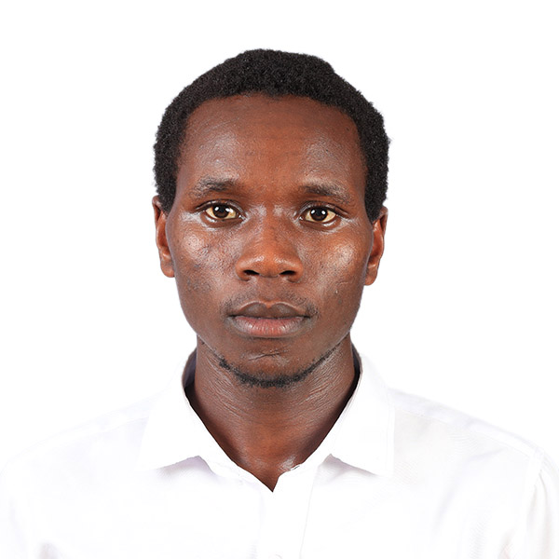

Po. Box 422, Masimba

Telephone: 0710198021 or 0112196873

Email:marubeduke2001@gmail.com

ID: 39303053

**PERSONAL INFORMATION**

**Marital Status** Single

**Date of Birth 2001**

**Gender** Male

**Religion** Christian

**Nationality**  Kenyan

**Language** English & Kiswahili

**PROFESSIONAL PROFILE**

A motivated and visionary General Nurse able to work well with a team and keep a consistently high-level quality of work ethics. I am seeking to work in a dynamic organization that seeks to create solutions to health needs while gaining work experience and help in realising the organization’s goal.

**PROFESSIONAL OBJECTIVE**

To be a competent, reliable, resourceful and analytical scientist(Nurse) with a mission to utilize the knowledge and skills acquired professionally in Nursing to better the physical, mental and social well-being of the society. This is achieved through working in hospitals and doing research in the field of Nursing, Health, Health Statistics, Health Economics, Epidemiology, Healthcare project Monitoring and Evaluation and Health Need and Assessment.

**EDUCATION BACKGROUND**

**2019-2023**  **CHUKA UNIVERSITY**

**DEGREE** Bachelors of Science in Nursing

**2014-2018** **MOI HIGH SCHOOL- GESUSU**

**Course** Kenya Certificate of Secondary Education (KCSE), (B+, 70 Points)

**2005-2013** NYAGEMI  **PRIMARY SCHOOL**

**Course** Kenya Certificate of Primary Education (KCPE), (348 Marks)

**PROFESSIONAL EXPERIENCES**

**May - December 2021: Embu Provisional Teaching and Referall Hospital.**

**October - December 2022: Embu Provisional Teaching and Referall Hospital.**

**May- June 2023: Chuka General Hospital.**

**Julne- July 2023: Muthambi Health Center.**

**July, 2023 - present : Embu Provisional Teaching and Referall Hospital.**

**Roles**

* Trained Intergrated Maternal Child Health Nurse
* Trained medical- Surgical Nurse
* Trained Midwife
* Trained Pediatrician Nurse.
* Trained Newborn Unit Care Nurse.
* Trained Rural health management.
* Trained Ward Management.
* Trained Theatre Nurse.

**OTHER PROFESSIONAL QUALIFICATIONS**

* High level of knowledge and understanding in MS Office: Word, Excel, Access and PowerPoint.
* Knowledge of computer applications and knowledge of data entry in databases.
* Knowledge of Medical terminologies
* Online Academic writing

**PROFESSIONAL SKILLS AND COMPETENCES**

* Competent team player and high level of flexibility.
* Good oral and communication skills.
* Good leadership skills.
* Good analytical problem solving skills.
* Mentorship skills.
* Customer service skills.
* Data oriented skills
* Reporting skills
* Research skills.

**LEADERSHIP RESPONSIBILITIES AND ACHIEVEMENTS**

**2015 - 2018:** Class Spiritual Leader, Moi High School, Gesusu.

**2016-2018:** School Church Choir coordinator.

* 1. Devoted Church Leader, Chuka University SDA. Church

**Roles**

* Deacon
* Sabbath School Director.

**HOBBIES AND INTEREST**

* Sports - football
* Event planner
* Creativity

**REFEREE**

Miss Elizabeth Mutunga Lecturer, School Of Nursing and Public Health, Chuka University.

PO. Box 109-60400, Chuka

Telephone: 0720598140

Email: elizamutunga64@gmail.com

Mr. Koome Impwi Lecturer, School of Nursing and Public Health, Chuka university

PO. Box 109-60400, Chuka

Telephone: 0720 833787

Email: koomeimpwii@gmail.com

Mr. Akoko Geoffrey: Lecturer,

Faculty of Life Sciences & Natural Resource Management, Tharaka University.

P.O. Box 193-60215, Marimanti.

Telephone: 071169186.

Email: [Akoko.geoffrey@tharaka.ac.ke](mailto:Akoko.geoffrey@tharaka.ac.ke)

